Elevator Pitch – Campaign 2024 General Elections
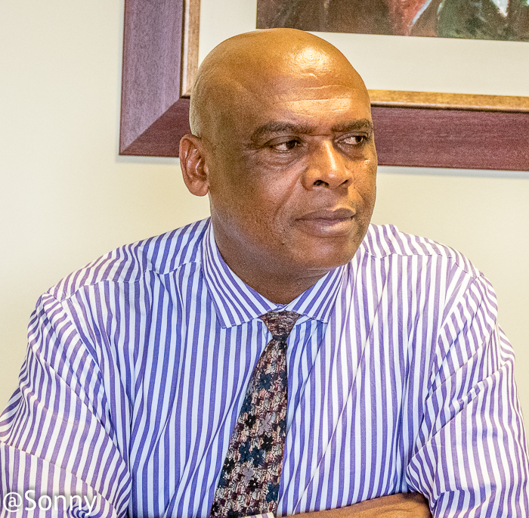
Name: Dumisani Xhakaza – Convener of Digital Party South Africa
Office: President
Key Issue Digitisation of the Political Economy of SA
Mr Dumisani Xhakaza BA(Wits) BA(Hons)(UKZN) HDipEd(PG) (Wits)

Fellow citizens, ladies and gentlemen
I stand before you today as the candidate for the highest office in our great nation, the Presidency, driven by a vision that extends far beyond politics – it’s about transforming our future through digitization. My campaign is rooted in a commitment to harnessing the power of technology to usher in a new era of progress, prosperity, and opportunity.
Our country is at crossroads, facing challenges that demand innovative solutions. As a future leader, I bring to the table a deep understanding of our political economy, a patriotic spirit, and unwavering family support. I am not just a candidate, I am a catalyst for change.
I envision a nation where digitization isn’t just a buzzword but a driving force behind new skills, new industries, and new entrepreneurs. It’s about creating new job opportunities for our people and building a vibrant digital economy that propels us into a future of endless possibilities.
My approach is holistic, addressing not only economic concerns but also the well-being of our young people. I am deeply troubled by the deteriorating standard of living and the political party bureaucracy that breeds corruption and incompetence. It is a time for a transformative shift – a shift towards a government that is efficient, transparent, and accountable to its people.
I am not here to make promises. I am here to deliver results.
Through embracing technology, we will combat corruption, fraud, and crime, ensuring that every citizen can trust in the integrity of our institutions.
This isn’t just a campaign promise. It’s a commitment to creating a society where everyone has the opportunity to thrive.
I’m well read, informed, and driven by passion for the well-being of our nation.
Together, we can overcome the challenges that have held us back for too long.
Let us break free from the shackles of political coalitions that have led to the failure of service delivery and the breakdown of public infrastructure.
Join me in this journey towards a future where our country stands tall on the global stage, where innovation and progress define us. The time for change is now, and with your support we will forge a path to a brighter tomorrow.
Vote DIGSA!
Vote the Digital Party South Africa!
Reboot! No Regret!
Please visit our website https://digitalpartysouthafrica.org.za and DONATE GENEROUSLY to make our vision a reality
Thank You.

